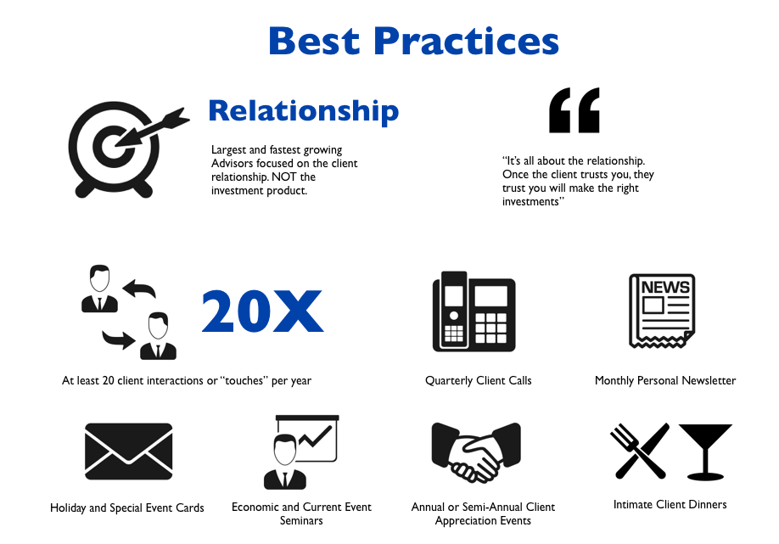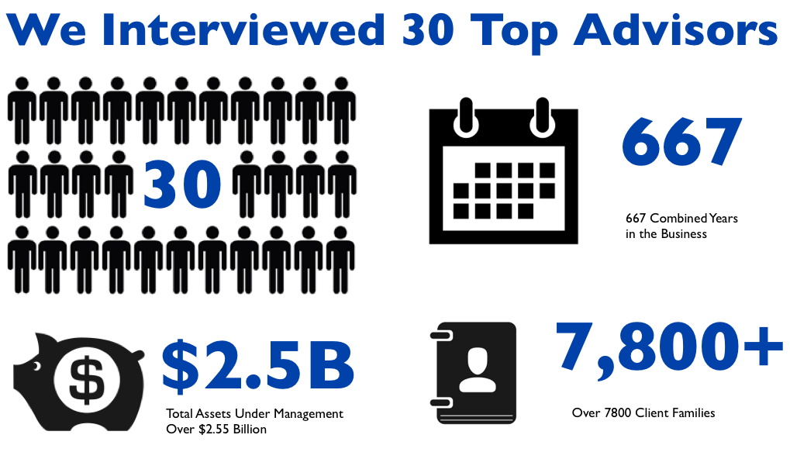

**Planning for the Future of Financial Services in Canada**

Canada’s financial services industry is undergoing a major transformation. When amendments to National Instrument 31-103 became law on July 15th 2013 it prompted us to launch the “CSA Full Disclosure 2016” Research Project (what we’ve termed “Disclosure 2016”). The goal of the project was simple, to determine a set of best practices to proactively prepare for the coming changes.

**Our initial objective was to understand how much of a threat advisors saw, and what they intended to do about it.**

The methodology we planned to use was fairly classic. First, we would start with an environmental scan of what was occurring in other jurisdictions where similar legislation has been enacted. In particular, this would entail research in the U.K. and Australian markets where similar changes had become mandatory on January 1st, 2013, and July 1st, 2013 respectively.

Second, we planned on interviewing at least 30 financial advisors to get feedback on how much of a threat they saw with Disclosure 2016, and what they intended to do about it.

Third, as part of the interviews, we intended to test out a few solutions that we had developed.

In time, we expected that we would be able to identify the best practice solutions to prepare for “Disclosure 2016” that would work for Canadian financial advisors, and that there was likely a business/consulting opportunity that we would be able to address to assist those financial advisors to implement those solutions.

**What we found was unexpected**

Now, just before we get to the unexpected part, we did finish the tasks we had originally set out to complete. We did the environmental/literature review of what was occurring elsewhere. And we interviewed 30 advisors and collected information on each financial advisor we interviewed: the size of their book, how long they’ve been in the industry, what type of charging model they use (DSC vs. FE 0% vs. fee based), etc. We obtained the Advisors’ thoughts on the Disclosure 2016 issue, and what, if anything, they intended to do about it. And we also tested out a few solutions that we developed. All of this is provided in detail in Appendix A.

**The unexpected part came in the form of a recurring theme.**

As we investigated the advisor concerns about Disclosure 2016, we began to notice a recurrent theme: while advisors expressed concerns about the regulatory changes, they were more inclined to talk about the challenges they were having with business development and practice improvement. Many advisors seemed to hit a “ceiling of complexity” at a point in their business where they make a comfortable living but they are not able to grow their book to the next level. Almost every advisor felt that they should be doing more from a marketing and practice development perspective, but most weren’t doing it. In simple terms, they felt that they were under-performing. At this point in our research project, we decided to open up the questioning with advisors to get a better understanding of the areas that they were most concerned with.

**We found that advisors were more interested in finding solutions to their current business development and practice improvement challenges.**

**Upon further investigation, we found that the greatest cause of advisor under-performance was the habit of attending to the service issues of existing clients to the exclusion of marketing and practice development initiatives**.

Given the option between a focus on the immediate service needs of an existing client and the important, but not urgent, marketing and practice improvement activities, the latter are pushed until tomorrow, and then tomorrow, and rarely get accomplished. This finding prompted us to investigate further to understand how some advisors were able to overcome this issue and grow to $100 million in assets under administration while so many others were not.

To understand what was happening, we first had to get a grasp on the differences between the two groups of advisors. The first group, those stuck under the “ceiling of complexity” had typically grown their book to a certain level the traditional way -- through personal connections, networking and in many cases a proactive marketing program. The typical makeup of this practice was a two person team, an advisor and an administrative assistant, who in many cases was a spouse. In every single case we interviewed, the second group, those who were able to break through and continue growing, had a team of several support staff. Now this may seem obvious given the difference in revenue generated between a $30 million book and a $100 million book, but the day to day activities and the strategic focus of the two groups of advisors were vastly different. We found that the first group spent the majority of their time in a **reactionary role**, dealing directly with client issues and preparing investment recommendations, retirement plans, RRSP contributions, etc. as required. The second group had a much more **strategic and proactive approach** to how they ran their business. They had specific goals in mind and matched their activities to those goals.

**We believe that what we discovered has the potential to**

**change the way many advisors grow their businesses.**

Next we looked at the day-to-day activities and they proved to be very different. The reactive group spent the majority of their time working “in” their business, making client calls, dealing with client service issues and other needs as they arose and prospecting when possible – which wasn’t often. For the proactive group on the other hand, time is spent leading their team and on marketing and practice improvement activities aimed at building or strengthening the personal relationships with clients and prospects. **This proactive group enjoyed a clear strategic advantage as they were able to focus their efforts on the highest value use of their time,** while the reactive group typically defaulted into taking care of lower value service issues and administrative tasks.

At this point we looked to understand more about how these proactive advisors ran their businesses and what kind of charging model (DSC vs. FE 0% vs. fee based) was employed. In almost every case we found that the large advisors were now earning their revenue using a front end zero or a fee based structure with a strong and growing bias to the latter. In all but one case, the advisors with over $100 million in AUM were either fully fee based or in the process of transitioning to fee based.

Given this finding, we next looked to understand how these large advisors established their teams and set up their businesses, to see if there was a repeatable process for other advisors to adopt. This is where another unique finding surfaced. In every single case examined, the advisor set up their team in a time where they were earning revenue from Deferred Sales Commissions (DCS). The DSC commissions were an important factor as the upfront investment in salary of a marketing and business development person at $40K - $60K or more could be funded immediately by the new income generated. When asked how they would do this again today these advisors were at a loss for solutions. This gave us another reason for advisor under-performance: **advisors at modest AUM are challenged with having to accept a significant cash flow “hit” if they wish to obtain the knowledge and personnel to develop marketing and practice development initiatives.** Without the up-front cash flow of DSC commission, the advisor trying to break through the “ceiling of complexity” must incur the burden of significantly reduced cash flow if they are to move their practice to the next level. This is an important finding, as with the new full disclosure regulations, DSC commissions may become a thing of the past.

**We found two main reason for underperformance: a habit of focusing on the urgent but not important, and challenges with affording additional support staff.**

**Solutions to the two main reasons for advisor under-performance**  
Our understanding of these two main reasons for under-performance brought us to a new concept for the offering we’d take to Canadian financial advisors.  We’ve branded it the “Do It For Me” solution.  As the name implies, “Do It For Me” means that the advisor need only decide on what marketing program or practice development issue he or she would like to execute, and then have an experienced service provider “Do It For Me”.  This solution has multiple benefits for the advisor:

* The advisor remains focused on his or her main competency:  meeting with clients, dealing with client issues and strengthening the personal client relationship;
* Execution of the marketing and/or practice development initiatives is performed by an organization that has the experience and know-how of executing many of these programs;
* The advisor does not have to hire a marketing/practice development assistant at a large fixed cost; instead, an experienced service provider executes the program or initiative at a much lower and variable cost to the advisor;
* Once the marketing or practice development program is selected, the advisor can rest assured that program will be implemented – a joint accountability of the service provider being accountable to the advisor and the advisor (and staff) being accountable to the service provider ensures that execution will take place.

As we continued to interview advisors, we tested out this concept and we knew we had a winner.  Interestingly, one of the benefits the financial advisors saw in this model was the accountability that they would have to an outside group of professionals as that group took the lead role in executing the marketing program.  Many advisors saw this process as being able to break the pattern of inertia that they were susceptible to.

**The most important finding from the proactive group was a focus**

**on developing a strong personal relationship with the client.**

With our solution in hand, we next looked to determine what specific types of programs would most efficiently lead to acquisition and retention of clients. What we found was surprising:  the most successful of the advisors we interviewed did not have a primary focus on investment strategy or any particularly sophisticated financial planning concept.   Instead, they had a primary focus on strengthening the personal relationship with the client. As one extremely successful advisor expressed “if you have the strong personal relationship, the client will accept any reasonable investment strategy or anything else the advisor recommends.” The initiatives that we would consider to be “Best Practices” therefore, would be those that focused on strengthening that personal relationship with the client. These Best Practices include:

**Personal Monthly Newsletters** (to clients and prospects) – The newsletter must be current and topical, and written in the first person. Clients know a “canned” newsletter when they see one, and they don’t perceive a “canned” version to be personal. Every newsletter should include at least one personal life development, such as son/daughter graduations, new family pet, weight loss goal/personal resolution, or community involvement activities. The goal is to build a relationship on a personal level.

**Quarterly Client Call Rotation** – These are telephone calls to check in quarterly. To enquire about any concerns, any life changes, any reason that the client may wish to speak to the advisor. These are not sales calls.

**Holiday and Birthday Cards** – Best practice for the holiday greetings card is a family photo. Second best is the advisor’s team photo. All types of cards have a hand written signature. Again, a personal touch. Advisors using this system report that some clients actually keep the annual holiday picture every year, and some display it in plain view with their other family pictures.

**Client Appreciation Events** – These events are an opportunity to personally connect with clients and thank them for their business. These events can also generate referrals, particularly when clients bring their friends.

**Economic/Current Event Seminars** – One-off events to keep clients up to date on current economic events. For example, the U.S. debt ceiling and implications to client portfolios.

**New Product Seminars** – Seminars to discuss new financial instruments. For example, the new G5/20 offering from CI. For strengthening relationships with both prospects and existing clients.

**Intimate Client Dinners** – An opportunity for a night out with 6 to 8 top client couples and a “best friend couple,” with an opportunity for the advisor to meet some new prospects. The advisor gets to mingle before dinner, touch base during dinner, and speak over dessert and afterward with prospects and existing clients.

All of these Best Practices are activities focused on building a strong personal relationship supported with frequent contact.

**Summary, Birth of a New Company, a New Service Offering, and Next Steps**

As we had indicated in the introduction to this report, we had intended to do research into the new CSA regulatory changes to National Instrument NI31-103 to identify what level of threat this presented to advisors, and what the potential solutions might be. We expected that this may present a business/consulting opportunity that a newly formed organization would address.

As we detailed in the early part of this report, something unexpected happened. Yes, there were some concerns about regulatory changes that were coming, but advisors expressed more concern about current challenges with moving to the next level from a marketing and practice development standpoint.

So, we changed our direction slightly and set out to discover what the over-arching problems were and how to address them. And we believe we found the answers. The two main problems we discovered were that a) advisors were falling victim to a habit of attending to the day-to-day needs of existing clients to the exclusion of marketing and practice development initiatives; and b) advisors needed to build their support teams, especially in the areas of marketing and practice development, but had difficulty incurring the cash flow burden of hiring such expertise.

**The Birth of Advisor Works and the “Do It For Me” Offering**

Our understanding of these two main reasons for under-performance brought us to a new concept for the offering we’d take to Canadian financial advisors, delivered by ADVISOR WORKS, a new company developed exclusively for this purpose.  We’ve branded the offering the “Do It For Me” solution.  As the name implies, “Do It For Me” means that the advisor need only decide on what marketing program or practice development issue he or she would like to execute, and then have ADVISOR WORKS “Do It For Me”.  This solution has multiple benefits for the advisor: a) The advisor remains focused on his or her main competency:  meeting with clients, dealing with client issues and strengthening the personal client relationship; b)Execution of the marketing and/or practice development initiatives is performed by ADVISOR WORKS, which has personnel with the experience and know-how of executing many of these programs; c) The advisor does not have to hire a marketing/practice development assistant at a large fixed cost; instead, ADVISOR WORKS executes the program or initiative at a much lower and variable cost to the advisor; d) Once the marketing or practice development program is selected, the advisor can rest assured that program will be implemented – a joint accountability of ADVISOR WORKS being accountable to the advisor and the advisor (and staff) being accountable to ADVISOR WORKS ensures that execution will take place.

**Mission of ADVISOR WORKS**

ADVISOR WORKS has a singular mission: to help Canadian financial advisors acquire and retain clients at an acceptable cost. ADVISOR WORKS accomplishes this with a unique approach known as “Do It For Me” which overcomes advisor challenges with a) habitually focusing on existing client issues to the exclusion of marketing and practice development initiatives; and b) cash flow challenges when hiring marketing and practice development expertise.

**Unique Selling Proposition**

**At ADVISOR WORKS we execute your marketing and practice development programs. We “Do It For You” at a variable cost.**

There are dozens of marketing consultants and gurus servicing the financial advisor market. They all focus on telling you what to do. Some coach you on how to do it. But the issue of execution remains -- none of them DO IT FOR YOU. At ADVISOR WORKS we take the burden of implementation of marketing and practice development activities off your plate – we “Do It For You.”

**That’s right…we “Do It For You”**

We’ve identified the Best Practices -- we’ve Done It For You. These are the practices that the most successful advisors regularly do, culled from our in-depth interviews, teachings of the “Gurus,” and an environmental/literature scan. And as you might expect, deepening the client relationship is the primary goal of most of the Best Practices activities.

We’ve built the “Repository of Best Practices”. This is a database of 17 years worth of accumulated concepts that work – compiled by a former Investment Dealer executive and a Senior Financial Advisor. You access marketing programs or practice improvement initiatives that satisfy Best Practices and We Do It For You.

**We’ve been there – the experience base is deep**

We can “Do It For You” because we’re former financial advisors and administrators. We’ve Done It For Ourselves, and we can Do It For You.

**Next Steps**

**For more information on our Do It For Me services please contact Rob Friday, President of Advisor Works at** [**rfriday@advisorworks.ca**](mailto:rfriday@advisorworks.ca) **or visit our website at** [**www.advisorworks.ca**](http://www.advisorworks.ca) **and request a consultation with the Advisor Works team.**

**APPENDIX A**

**The Impact to Canadian Financial Advisors of CSA Amendments to National Instrument 31-103**

**ORIGINAL PROJECT SCOPE**

**Project Goal**

To develop a turnkey program for advisors to:

* understand the upcoming regulatory changes;
* determine the threat level to the advisor’s practice; and,
* provide strategies to mitigate the threat.

**Project Methodology**

Perform an environmental scan/literature review of experiences where similar regulatory changes have occurred in other jurisdictions. Conduct 30+ interviews with Canadian advisors and summarize findings in a program to be provided to Canadian financial advisors for dealing with the regulatory changes.   
  
**Project Deliverables**

Once completed, the environmental scan/literature review and advisor interviews will be reviewed and organized into a report with findings, risks to advisors of losing clients, options available to advisors, and recommendations.

**Additional Offerings**

For those advisors who wish to take action, Advisor Works, a new company established to address a variety of advisor needs, will provide the following additional offerings:

* guides to help advisors determine the threat to their specific practice, group advisor trainings, online and webinar trainings, other offerings to be determined;
* presentation materials to help advisors educate clients about fees and commissions and the regulatory changes;
* a full list of services and offerings available to demonstrate value-for-money to clients ;
* process for transitioning from Front End or DSC to a fee based model.

**Environmental Scan/Literature Review**

The first step in our process was to conduct an environmental scan/literature review of other jurisdictions where similar regulatory changes have already been enacted. We found relevant information from Australia and the U.K.. The Australian regulatory changes, which include an elimination of all commissions, the adoption of “Statutory Best Interest Duty” (interchangeable with “Fiduciary Duty”) and a requirement to “opt in” to the relationship (in writing) every two years, were deemed to be too different from upcoming Canadian regulatory changes to warrant inclusion in this report. The U.K. situation was similar to the Canadian changes, although there were some material differences, noted below.

Key Environmental Scan/Literature Review Findings:

* Key difference with U.K. regulatory changes was the U.K. elimination of all commissions. Fee based is the only option available to U.K. advisors;
* The media coverage of the new laws was unfavorable to the financial services industry. Public reaction was biased by the negative media coverage;
* Deloitte study finds that U.K. clients are not well informed about compensation to dealers and advisors – incredibly, 87% of customers who purchased a savings/investment product in the last three years from a bank advisor thought the advice process was free;
* Ernst and Young expects 33% of U.K. advisors to drop out of business;
* Actual results to date: Number of registered individuals (advisors) dropped from 33,583 in first quarter, 2011, to 27,959 in third quarter 2012, an actual drop of 17% so far;
* 52% of U.K. advisors have indicated concerns about their ability to remain profitable leading to a mass exodus of advisors from the industry;
* 38% of advisors felt more pressure to justify fees; and,
* 50% of U.K. advisors initially expected that complying with the new regulations would be an onerous task. Following implementation, 48% felt their expectations were accurate and 38% believed meeting the requirements was more difficult than they expected.

In Canada, the amendments to NI 31 – 103 that are likely to cause most concern for advisors are: a) a requirement to provide full disclosure on dealer compensation and charges, and b) a requirement to provide an investment performance report detailing the rate of return and other information by account. To appreciate how prescriptive these amendments are, the detailed amendment describing these two amendments is provided in Appendix B.

In summary, the environmental scan/literature review suggests that the regulatory changes represent a real threat to many advisors’ businesses.

**Advisor Interviews – Findings, Implications and Conclusions**

In total, we interviewed just over 30 advisors. Their responses were very forthcoming – in no instance did we have an advisor refuse to provide an answer to any our questions. A summary of the size of practice, type of charging model, and other data is provided in Appendix C.

**Risk of losing clients**

As the amendments to NI 31-103 are enacted, some advisors will be more at risk for losing clients than others. Based on the environmental scan/literature review and the interviews of over 30 advisors, we see the following risks with respect to losing clients:

* Advisors who are not taking a proactive approach to building a **personal** relationship with clients outside of investment advice will be at risk for losing clients;
* Advisors who are using the DSC charging model will receive the most negative reporting by the media and will be more at risk of losing clients. In particular, those advisors who have charged an up front DSC commission in the preceding 12 month period will have the most risk of client disaffection as these commissions will be captured by the new reporting requirement;
* Clients who are not well informed on how advisors and dealers are compensated will be more likely to suffer “sticker shock” as they find out how much their advisors/dealers have been earning from their accounts. Advisors of these poorly informed clients will be more at risk of damaging or losing the relationship;
* In the first year after making an investment for their clients, advisors who opt to use the Front End Zero charging model are more favorably positioned than those earning DSC, as the total income in the first year will be lower for the FE0% advisor (only about one-fifth of the DSC amount). However, in years two to the end of the DSC schedule, those advisors using the DSC charging model will have only about one-half of the trailers of the FE0% advisor.
* Advisors currently using a Fee Based charging model are in the lowest risk position as fees have been discussed, are already transparent and out-boarded.

**Options Available to Advisors**

Based on our interviews, advisors identified four strategies for responding to the regulatory changes:

* **Wait and See**: Many advisors have indicated that they intend to wait and see what will unfold. This appears to be a risky proposition as we expect the media to begin commenting on the regulatory changes well in advance of the July 15, 2016 implementation deadline. We also expect the coverage to incite clients to become more vigilant about advisor/dealer compensation. This may cause the advisor to lose control of the conversation and put clients at risk of deciding to leave the relationship before the advisor has an opportunity to provide his/her explanation regarding the new regulations.
* **Side-step the Regulatory Changes:** Some advisors have noted that the insurance industry is not subject to the regulatory changes affecting the security industry. For those advisors who are dual licensed, there has been some discussion that they may to move to segregated funds and avoid the disclosure and other new regulatory requirements. Although this is technically possible, we do not expect many advisors will wish to incur the administration required to effect this change. Further, defending this change with clients and compliance departments will present difficult ethical challenges.
* **Educate the Client**: This appears to be the most common strategy. The education requirement is multifaceted:
  + how advisors and dealers receive compensation;
  + the regulatory changes and new requirements for dealers and advisors;
  + value for the fees clients pay – primary source of compensation and all the services it pays for.

It is our view that this client education process must begin well before the media begins their expected coverage of the regulatory changes.

* **Move Clients to a Fee Based Charging Model:** This is probably the most effective option, but not all advisors have adopted or plan to adopt the Fee Based model. Nevertheless, by moving to the Fee Based model, advisors can control the conversation and de-sensitize clients to the media coverage and create a “win-win” by transitioning to a fee based model.

**Recommendations**

Based on the environmental scan/literature review and the advisor interviews we completed, we offer the following recommendations to advisors:

* Don’t wait. Regardless of which option you may choose, do not wait, as this will have two negative effects. First, waiting will allow the media to “seize the higher ground” by developing their arguments first. We expect the general tone to be somewhat sensational as stories focus on how clients are surprised by the compensation paid to the advisor/dealer. We further expect that some of the stories will report how some clients intend to leave their advisor in order to save the money that has been paid to the advisor/dealer. Second, waiting means that you will find yourself in a defensive/reactive mode answering difficult and possibly aggressive client questions rather than providing proactive and calm explanations related to your/your dealer’s compensation, new reports that the client will be receiving, etc.
* If you are a DSC oriented advisor, consider opting for a different charging model beginning in 2015, and possibly permanently. The ideal solution is to move to a Fee Based model. In doing so, advisors report that they have made a strong case to their clients that not only is the fee based model more honest and transparent, there is also an opportunity to move to a lower total cost solution (using ETFs or programs like Dynamic Fund Analytics). Some advisors are able to increase their average fee to 1.25% or higher while still lowering total cost to the clients.
* If you are a FE0% oriented advisor, consider either the fee based option detailed above, or prepare a value-for-money argument for presentation to your clients. We suggest positioning the compensation received from the MER of the mutual funds you use as a “Mutual Fund Retainer” that is used to pay for all types of services that the advisor and his/her dealer can potentially provide. We envision detailing every conceivable service that might be performed for the client over the client’s lifetime. The value-for-money explanation would focus on how the Mutual Fund Retainer provides the funding to pay for all of those services.
* Educate your client before the media does. Regardless of which option you adopt, get to your clients before the media. Let them know what is coming in the regulation, and explain how the media is likely to portray it all. Have your clients effectively “desensitized” by the time the media begins to inundate the various print, TV and radio channels with their perspectives.

**NEXT STEPS**

If you have read the entire report and all the Appendices, you know that the needs of Canadian financial advisors have spawned a new company called Advisor Works. You will also know that Advisor Works will help advisors overcome some important challenges to deliver more new clients and retain more existing clients. And Advisor Works has created a menu of service offerings to help advisors achieve their goals. One of the service offerings is called “Disclosure 2016” which has Advisor Works helping advisors to deal with the challenges created by amendments to NI 31 – 103. To that end, Advisor Works has developed a turnkey program to:

* understand the upcoming regulatory changes;
* determine the threat level to the advisor’s practice; and,
* provide strategies to mitigate the threat.

If you would like assistance with your response to the upcoming regulatory changes, contact Rob Friday, President of Advisor Works at [rfriday@advisorworks.ca](mailto:rfriday@advisorworks.ca) or visit our website at www.AdvisorWorks.ca and make a request.

**APPENDIX B**

**Two amendments to National Instrument 31 - 103 likely to affect Canadian financial advisors**

The two changes most likely to affect Canadian financial advisors and their clients have to do with a) a requirement to provide full disclosure on dealer compensation and charges, and b) a requirement to provide an investment performance report detailing the rate of return and other information by account. To provide a sense as to how prescriptive the changes are, these amendments have been lifted the material below right from the **BLACK-LINE OF AMENDMENTS TO NATIONAL INSTRUMENT 31-103, *REGISTRATION REQUIREMENTS, EXEMPTIONS AND* *ONGOING REGISTRANT OBLIGATIONS***:

**14.17 Report on charges and other compensation**

For each 12-month period, a registered firm must deliver to a client a report on charges and other compensationcontaining the following information, except that the first report delivered after a client has opened an account may cover a period of less than 12 months:

(a) the registered firm’s current operating charges which might be applicable to the client’s account;

(b) the total amount of each type of operating charge related to the client’s account paid by the client during the period covered by the report, and the total amount of those charges;

(c) the total amount of each type of transaction charge related to the purchase or sale of securities paid by the client during the period covered by the report, and the total amount of those charges;

(d) the total amount of the operating charges reported under paragraph (b) and the transaction charges

reported under paragraph (c);

(e) if the registered firm purchased or sold debt securities for the client during the period covered by the report, either of the following:

(i) the total amount of any mark-ups, mark-downs, commissions or other service charges the firm

applied on the purchases or sales of debt securities;

(ii) the total amount of any commissions charged to the client by the firm on the purchases or sales of

debt securities and, if the firm applied mark-ups, mark-downs or any service charges other than

commissions on the purchases or sales of debt securities, the following notification or a notification

that is substantially similar:

*“For debt securities purchased or sold for you during the period covered by this report,*

*dealer firm remuneration was added to the price you paid (in the case of a purchase) or*

*deducted from the price you received (in the case of a sale). This amount was in addition*

*to any commissions you were charged.”;*

(f) if the registered firm is a scholarship plan dealer, the unpaid amount of any enrolment fee or other charge that is payable by the client;

(g) the total amount of each type of payment, other than a trailing commission, that is made to the registered firm or any of its registered individuals by a securities issuer or another registrant in relation to registerable services to the client during the period covered by the report, accompanied by an explanation of each type of payment;

(h) if the registered firm received trailing commissions related to securities owned by the client during the period covered by the report, the following notification or a notification that is substantially similar:

*“We received $[amount] in trailing commissions in respect of securities you owned during the 12-*

*month period covered by this report.*

*Investment funds pay investment fund managers a fee for managing their funds. The managers*

*pay us ongoing trailing commissions for the services and advice we provide you. The amount of*

*the trailing commission depends on the sales charge option you chose when you purchased the*

*fund. You are not directly charged the trailing commission or the management fee. But, these fees*

*affect you because they reduce the amount of the fund’s return to you. Information about*

*management fees and other charges to your investment funds is included in the prospectus or fund*

*facts document for each fund.”*

**(2)** For the purposes of this section, the information in respect of securities of a client required to be reported under subsection 14.14(5) [*account statements*] must be delivered in a separate report on charges and other compensation for each of the client’s accounts.

**(3)** For the purposes of this section, the information in respect of securities of a client required to be reported under subsection 14.14.1(1) [*additional statements*] must be delivered in a report on charges and other compensation for the client’s account through which the securities were transacted.

**(4)** Subsections (2) and (3) do not apply if the registered firm provides a report on charges and other compensation that consolidates, into a single report, the required information for more than one of a client’s accounts and any securities of the client required to be reported under subsection 14.14(5) or 14.14.1(1) and if the following apply:

(a) the client has consented in writing to the form of disclosure referred to in this subsection;

(b) the consolidated report specifies the accounts and securities with respect to which information is required to be reported under subsection 14.14.1(1) [*additional statements*].

**(5)** This section does not apply to a registered firm in respect of a permitted client that is not an individual.

**14.18 Investment performance report**

**(1)** A registered firm must deliver an investment performance report to a client every 12 months, except that the first report delivered after a registered firm first makes a trade for a client may be sent within 24 months after that trade.

**(2)** For the purposes of this section, the information in respect of securities of a client required to be reported under subsection 14.14(5) [*account statements*] must be delivered in a separate report for each of the client’s accounts.

**(3)** For the purposes of this section, the information in respect of securities of a client required to be reported under subsection 14.14.1(1) [*additional statements*] must be delivered in the report for each of the client’s accounts through which the securities were transacted.

**(4)** Subsections (2) and (3) do not apply if the registered firm provides a report that consolidates, into a single report, the required information for more than one of a client’s accounts and any securities of the client required to be reported under subsections 14.14(5) or 14.14.1(1) and if the following apply:

(a) the client has consented in writing to the form of disclosure referred to in this subsection;

(b) the consolidated report specifies the accounts and securities with respect to which information is required to be reported under subsection 14.14.1(1) [*additional statements*].

**(5)** This section does not apply to

(a) a client’s account that has existed for less than a 12-month period;

(b) a registered dealer in respect of a client’s account in which the dealer executes trades only as directed by a registered advisor acting for the client; and

(c) a registered firm in respect of a permitted client that is not an individual.

**(6)** If a registered firm reasonably believes there are no securities of a client with respect to which information is required to be reported under subsection 14.14(5) [*account statements*] or subsection 14.14.1(1) [*additional statements*] and for which a market value can be determined, the firm is not required to deliver a report to the client for the period.

**Appendix C**

**30 Advisor Interviews – The Data**

**Study Findings**

Study Surveyed 30 Advisors

Total Assets under Management $2,550,000,000

Average AUM $85,000,000

Standard Deviation $78,045,080

Median $61,000,000

Range from $10,000,000 up to $340,000,000



Average Tenure 22 Years, Standard Deviation 10 Years



Average # of families 261, Standard Deviation 171



**Charging Model** – Many Advisors have a blended charging model for new money depending on client circumstances

8 Advisors use Deferred Sales Commission

21 Advisors Front End Zero (FE0%)

1 Advisor Front End 1%

14 Advisors Fee for service

Largest 10 compared to Smallest 10 Analysis

**10 Largest**

Average Tenure 28.1 Standard Deviation 6.0 Years

Total AUM accounted for $1,680,000,000

Average Families 408 Standard Deviation 185

Average Account $448,988 Standard Deviation $215,605

**10 Smallest**

Average Tenure 16.1 Years Standard Deviation 11.4 Years

AUM accounted for $265,000,000

Average Families 151 Standard Deviation 87

Average Account $229,447 Standard Deviation $139,735





Implications – Larger advisors have made a move to fee-for-service model.   
Many smaller advisors are on a DSC structure.

**Age of Clients**



